**St Mary’s Catholic Primary School**

**Science Curriculum Statement**

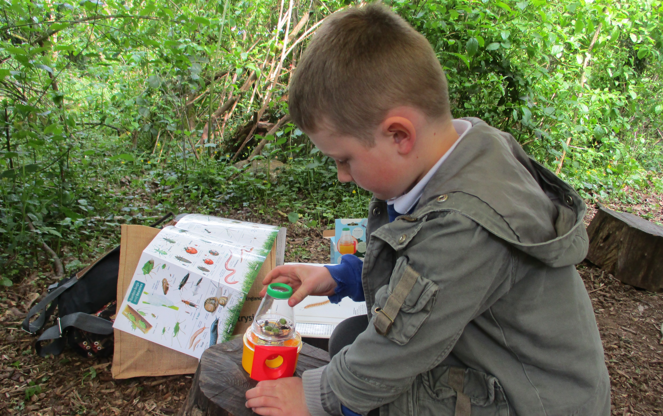

**INTENT**

At St Mary’s Catholic Primary School, the main aim of our Science studies is to ignite curiosity in our children; we want them to question why things happen and the way things work. The 2014 National Curriculum for Science aims to ensure that all children:

* develop scientific knowledge and conceptual understanding through the specific disciplines of biology, chemistry, and physics.
* develop understanding of the nature, processes, and methods of science through different types of science enquiries that help them to answer scientific questions about the world around them.
* are equipped with the scientific skills required to understand the uses and implications of science, today and for the future.

We understand that it is important for lessons to have a skills-based as well as knowledge-based focus. At St Mary’s Catholic Primary School, we know that children are naturally curious, and we encourage this inquisitive nature throughout their time with us and beyond. Science fosters a healthy inquisitiveness in children about our universe and promotes respect for the natural and life sciences. We believe science encompasses the acquisition of knowledge, concepts, skills, and positive attitudes. We ensure that the Working Scientifically skills are built-on and developed throughout their school career so that they can use equipment, conduct experiments, build arguments and explain concepts confidently and continue to ask questions and be curious about their surroundings. We believe that is also important to link science teaching to real life and look for opportunities to look into the lives of scientists, both past and present, working in different fields.

**IMPLEMENTATION**

Following the Plan Bee science scheme, teachers create a positive attitude to science learning within their classrooms and reinforce an expectation that all children can achieve high standards in science. Our whole school approach to the teaching and learning of science involves the following;

• Science will be taught in planned and arranged blocks by the class teacher fulfilling a full range of experience across a two-year rolling programme. This is a strategy to enable the achievement of a greater depth of knowledge and understanding

• Observational tasks will assess children’s knowledge and understanding to inform planning and to assess children’s progress following teaching.

• Through our planning, children are encouraged to ask their own questions and be given opportunities to use their scientific skills and research to discover the answers. This curiosity is celebrated within the classroom. Planning involves teachers creating engaging lessons, often involving high-quality resources to aid understanding of conceptual knowledge. Teachers use precise questioning in class to test conceptual knowledge and skills and assess children regularly to identify those children with gaps in learning, so that all children keep up.

• We build upon the skill development of the previous years. As the children’s knowledge and understanding increases through different blocks of work, and they become more proficient in selecting, using scientific equipment, collating and interpreting results, they become increasingly confident in their growing ability to come to conclusions based on real evidence.

• Working Scientifically skills are embedded into lessons to ensure these skills are being developed throughout the children’s school career and new vocabulary and challenging concepts are introduced through direct teaching. This is developed through the years, in-keeping with the topics.

• Teachers demonstrate how to use scientific equipment, and the various Working Scientifically skills to embed scientific understanding. Teachers find opportunities to develop children’s understanding of their surroundings by accessing outdoor learning and local environment visits. Specialist visitors deliver high quality workshops to facilitate and support science learning by building on the children’s prior knowledge and aspire them to think of their futures and their prospective career paths.

**IMPACT**

The successful approach at St Mary’s Catholic Primary School results in a fun, engaging, high quality science education, that provides children with the foundations for understanding the world. Our engagement with the local environment ensures that children learn through varied and first-hand experiences of the world around them. So much of science lends itself to outdoor learning and so we provide children with many opportunities to experience this. Through various workshops, trips and interactions with experts and local companies, children have the understanding that science has changed our lives and that it is vital to the world’s future prosperity. Children learn the possibilities for careers in science because of our community links and whole school focused science weeks. Children at St Mary’s Catholic Primary School overwhelmingly enjoy science, and this results in motivated learners.

|  |
| --- |
| **SCIENCE IN THE EARLY YEARS**  Science is explored through the children’s understanding of the world. Our outdoor learning environment in the Early Years at St Mary’s Catholic Primary School is key to enhancing child led learning. We provide opportunities for children to question, wonder, explore, discover, experiment, and observe through direct experiences. The children are introduced to scientific vocabulary to help them further their understanding and are asked open-ended questions, so that they can make predictions and give them opportunities to question. Our Early Years provision ensures that children have access to a range of materials that work in different ways for various purposes. Children can use resources and the environment around them to notice similarities and differences, changes over time such watching the trees change in our orchard, growing vegetables in our vegetable patch and exploring pond life. |