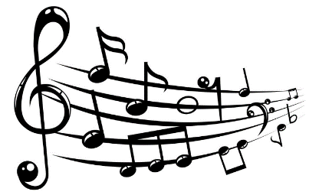**St Mary’s Catholic Primary School**

**Music Curriculum Statement**

At St Mary’s Catholic Primary School, we want every child to be happy and enthusiastic learners of Music, and to be eager to achieve their very best in order to fulfil their God-given talents. We firmly believe that the recipe for success is high quality first-wave teaching in Music, which is central to the life of our happy, caring school.

**INTENT- What are we trying to achieve?**

* Our principal aim is that children leave St Mary’s Catholic Primary School with a wide range of happy and rich memories in Music, formed through interesting and exciting experiences, driven through topics that enhance a child’s awareness of their own abilities and strengths as a learner; thus ensuring that children see learning in music as an ongoing process not a one-off event.
* Our high-quality music education will engage and inspire pupils to develop a love of music and their talent as musicians, and so increase their self-confidence, creativity, and sense of achievement.
* Opportunities will exist for children of all ages to experience learning beyond the classroom. This will allow them to enrich their knowledge by, for example, attending performances by professional musicians and participating in school productions as well as cross-Academy performances at Buckfast Abbey. One of our main links is with the choristership programme where children from Year 3 and beyond have the chance to become choristers for Buckfast Abbey. This incredible offer allows children a further 6 hours of music tuition in addition to a weekly individual singing and piano lesson. Other opportunities might include visits to concerts, meeting musicians, professional musicians visiting schools to work with pupils, musicians from other schools sharing their expertise with staff and children. All KS2 children have this opportunity.
* Children will meet the National Curriculum expectations in music, which will be taught by highly qualified staff who will support children to develop skills which in turn will enable them to develop a deeper understanding of the subject.
* All children will study music for a minimum of 30 minutes per week with continued opportunities for curriculum enhancement through music.
* Children will develop self-confidence and teamwork skills through performance. They will have opportunities to sing as a class, in smaller groups and as a school community. All children perform annually in the majestic setting of Buckfast Abbey.
* Children will learn to read and write staff notation, increasing their understanding of rhythmic and melodic notation.
* Children will understand how Catholic virtues and British Values relate to music through a study of music from different faiths and cultures.
* Children will listen to, review and evaluate a range of music across a range of historical periods, genres, styles and traditions, including contemporary music and the works of the great composers and musicians using subject specific vocabulary relating to the musical elements; instrumentation, metre, rhythm, pitch, dynamics, tempo, texture, structure and melody.  Where possible, children will use music technology to compose simple rhythms and melodies.

**Scheme of Learning- see separate link**

The Scheme of Learning follows the [National Curriculum](https://assets.publishing.service.gov.uk/government/uploads/system/uploads/attachment_data/file/239037/PRIMARY_national_curriculum_-_Music.pdf).

* The key areas of Listening and Appraising, Musical Activities *a.* Warm-up Games *b.* Optional Flexible Games *c.* Singing *d.* Playing instruments *e.* Improvisation *f.* Composition and Performing are developed throughout KS1 and KS2 in order to prepare children for secondary education.

**IMPLEMENTATION- How do we translate our vision into practice?**

* The curriculum hours in music are followed by all staff in the school.
* The subject leader and support for music will meet the SLT on a half-termly basis to evaluate provision and, where necessary, highlight staff training needs and meet all aspects of the job description.
* Carefully designed schemes of learning and medium-term plans in music ensure consistency and progress of all learners. These have been designed and evaluate by the subject lead and support and follow a careful progression of skills whilst enhancing curriculum topic learning where appropriate.
* Music is taught as an individual discipline but plays a key role in the achievement of the learning aims of the topic. For example, a focus on Anglo-Saxons could include composing the lyrics and music for the story of Beowolf to be included in a shared performance for family and friends. Criteria in every music lesson are set in order to guide children to achieve their potential. This ensures work is demanding and matches the aims of the curriculum.
* High quality teaching responds to the needs of children. Spiral learning is a key focus of all formative and summative assessment with teachers actively assessing lessons formatively in order to identify misconceptions early. Music journals will be used to record key objectives and children’s responses to their musical learning.
* High quality input from experts and educational resources complement the delivery of specialist learning admirably. Children understand how music is used in the wider world including careers.

**Assessment**

Charanga Music scheme is followed predominately in KS1 and a mix of Charanga and Topic driven themes are taught throughout KS2. Assessments are carried out formatively throughout the block of work, followed by a summative assessment at the end of each term. This is carried out by both the subject lead and support.

**Cross-curricular opportunities**

Where music is taught through a topic, this results in excellent cross-curricular opportunities. For example, a topic focusing on ‘Romans’ will result in the Music lessons including battle themed music, linked to an actual re-enactment of a Celtic/Roman battle such as Boudicca’s Final Battle. Through this, the children can really begin to connect with their emotions and realise the feelings and impact of these historical events, supporting recall of history and nurturing rich writing opportunities. Additional opportunities, such as performing these songs to parents, will also be encouraged. This ensures that children are engaged and interested in the subject through the excitement of the topic. It also allows for the British Values of tolerance and respect to be highlighted, understood and practised by children.

**Cultural Capital**

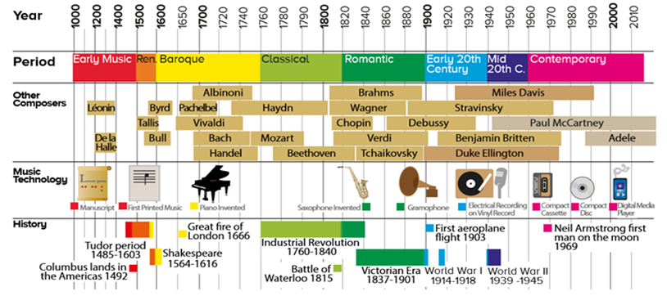Children will learn about key figures from Music history such as the Song of Caedmon, Byrd, Talis, Grieg,  
Saint Saens,Holst, Britten, Vera Lynn, David Bowie, Elton John and Hans Zimmer.

They will also experience the following during Key Stage 1 and 2:

* Meeting and talking to musicians
* Concert performances both in and out of school
* Playing a variety of musical instruments
* Playing in a band
* Singing in the choir
* Signing with the Newton Abbot Orchestra for the Rotary Charity Christmas Concert.
* Performing for charity luncheons, at Christmas Fayres and in Care homes – St. Andrew’s, Ashburton.
* Performing at large venues such as Buckfast Abbey with other choirs
* Singing in church liturgies each week and for key Liturgical Events such as Easter and Christmas.

**Impact – What is the impact of our curriculum on the children?**  
• Children are happy learners within Music. They experience a wide-ranging number of learning challenges in the art and know appropriate responses to them.  
• Through Music, children deepen their appreciation of their faith and fulfil their God-given talents  
• Visits within Music have enriched the lives of the children and they are able to discuss how the experience impacted their knowledge and understanding.  
• Children of all abilities and backgrounds achieve well in Music, reflected in outstanding progress that reveals a clear learning journey. Children talk enthusiastically about their learning in Music and are eager to further their learning in the next stages of their education.  
• There is a proven track record of outstanding outcomes as shown in pupils’ musical ability, their music journals (starting September 2020) and their enjoyment of the subject (see questionnaire). These indicators reflect the impact of deep learning.  
• Clear outcomes focus and guide all Music development plans and drive improvement.  
• Fundamental British Values are evident in Music and children understand how Music celebrates our wonderful differences.  
• Through wider reading in music, children will gain an appreciation and understanding of the background and historical context of music and of the lives and interactions of the composers. Through this exposure, children will produce work that is influenced by the best of the best.

**MUSIC IN THE EARLY YEARS**

Regular observations and assessments of learning are recorded in the children’s learning journey and contribute to a summative assessment at the end of EYFS using the Early Years Outcomes for Expressive Arts and Design.

|  |
| --- |
| **Skills covered through EYFS Framework:**  **Exploring and using media and materials.**  • Enjoys joining in with dancing and ring games.  • Sings a few familiar songs.  • Beginning to move rhythmically.  • Imitates movement in response to music.  • Taps out simple repeated rhythms.  • Explores and learns how sounds can be changed.  Begins to build a repertoire of songs and dances.  **Explores the different sounds of instruments.**   * Children sing songs, make music and dance, and experiment with ways of changing them.   **Being Imaginative:**  • Developing preferences for forms of expression.  • Uses movement to express feelings.  • Creates movement in response to music.  • Sings to self and makes up simple songs.  • Makes up rhythms.   * Captures experiences and responses with a range of media, such as music, dance and paint and other materials or words. * They represent their own ideas, thoughts and feelings through design and technology, art, music, dance, role play and stories |

#### One Final Thought. Why we teach music at St Mary’s.

#### Music is a science. Music is mathematical.

**Music is a foreign language. Music is history.**

**Music is Physical Education. Music develops insight and demands research.**

**Music is all these things, but most of all,**

**Music is Art**

**That is why we teach music:**

**Not because we expect you to major in music**

**Not because we expect you to play or sing all your life….**

**But so you will be human. So you will recognise beauty.**

**So you will be closer to an infinite beyond this world.**

**So you will have something to cling to**

**So you will have more love, more compassion,**

**More gentleness, more good –**

**In short, more Life.**

**(Author Unknown)**