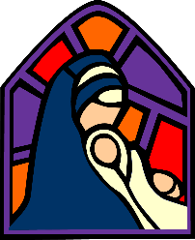
Access Art Split Curriculum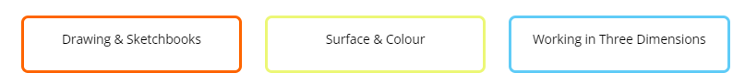
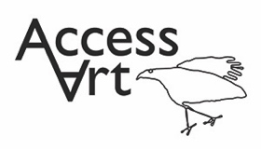 | Autumn Term | Spring Term | Summer Term
Year 1  Year A | Spirals  Using drawing, collage and mark-making to explore spirals. Introducing sketchbooks. | Simple Printmaking  Explore simple ways to make a print. Use line, shape, colour and texture to explore pattern, sequencing and symmetry. | Making Birds  Sculptural project beginning with making drawings from observation, exploring media, and transforming the drawings from 2d to 3d to make a bird.
Year B  ( as an alternative including a paint focus) | Spirals  Using drawing, collage and mark-making to explore spirals. Introducing sketchbooks. | Exploring Watercolour  Exploring watercolour and discovering we can use accidental marks to help us make art. | Playful Making  Exploring materials and intention through a playful approach.
Year 2 | Explore & Draw  Introducing the idea that artists can be collectors & explorers as they develop drawing and composition skills. | Expressive Painting  Explore how painters sometimes use paint in an expressive and gestural way. Explore colour mixing and experimental mark making to create abstract still life. | Stick Transformation Project  Explore how you can transform a familiar object into new and fun forms.  .
Year 3 | Gestural Drawing with Charcoal  Making loose, gestural drawings with charcoal, and exploring drama and performance.  . | Cloth, Thread, Paint  Explore how artists combine media to create work in response to landscape. Use acrylic and thread to make a painted and stitched piece. | Telling Stories Through Drawing & Making  Explore how artists are inspired by other art forms – in this case how we make sculpture inspired by literature and film
Year 4/ 5  Year A | Storytelling Through Drawing  Explore how artists create sequenced drawings to share and tell stories. Create accordion books or comic strips to retell poetry or prose through drawing. | Exploring Pattern  Exploring how we can use colour, line and shape to create patterns, including repeating patterns. | Sculpture, Structure, Inventiveness & Determination  What can artists learn from nature?
Year B | Storytelling Through Drawing  Explore how artists create sequenced drawings to share and tell stories. Create accordion books or comic strips to retell poetry or prose through drawing. | Exploring Still Life  Explore artists working with the genre of still life, contemporary and more traditional. Create your own still life inspired art work. | Festival Feasts  How might we use food and art to bring us together?
Year 5/ 6  Year A | Brave Colour  Exploring how artists use light, form and colour to create immersive environments. | 2D Drawing to 3D Making  Explore how 2D drawings can be transformed to 3D objects. Work towards a sculptural outcome or a graphic design outcome. | Exploring Identity  Discover how artists use layers and juxtaposition to create artwork which explores identity. Make your own layered portrait..
Year B | Typography and maps  Exploring how we can create typography through drawing and design, and use our skills to create personal and highly visual maps | Activism  Explore how artists use their skills to speak on behalf of communities. Make art about things you care about. | Take a seat  Explore how craftspeople and designers bring personality to their work.

