 | Roadford
Cycle |  | Autumn | Spring | Summer
No cycle | Roadford | Stone Age to Iron Age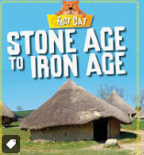 | Invaders and Settlers – Romans  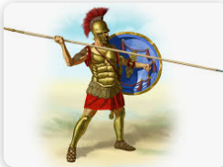 | What can we find out about ancient Egypt?  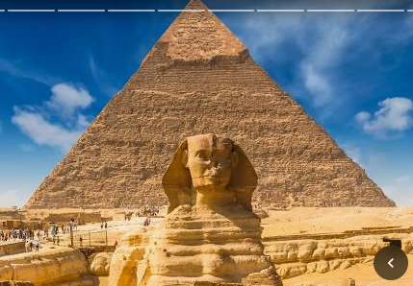
A | Fernworthy | Anglo Saxons Picts and Scots Plan Bee (Y4) 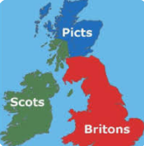 | The Shang Dynasty (Y5)  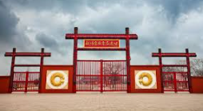 | The Mayans (Y4)  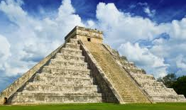
 | Burrator | Anglo Saxons Picts and Scots (scheme to be decided.) | The Shang Dynasty (Y5) | The kingdom of Benin (Y6)
B | Fernworthy | World War 2 (Y4)  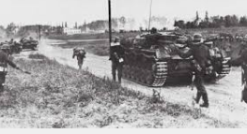 | Local Study | The Indus Valley (Y4)  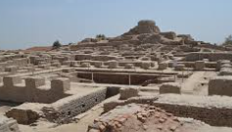
 | Burrator | Leisure and Entertainment (Y6) 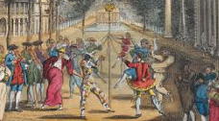 | Local Study | The Atlantic Slave Trade (Y6)  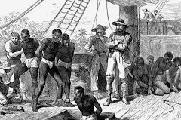
C | Fernworthy | Vikings vs Anglo Saxons (Y5)  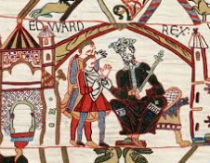 | Who were the Ancient Greeks (Y5)  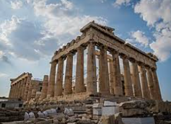 | Local Study
 | Burrator | Vikings vs Anglo Saxons (Y5) | Who were the Ancient Greeks (Y5) | Local Study

