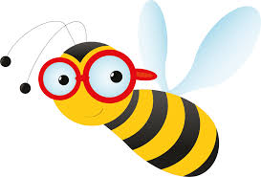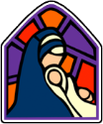St Mary’s Science Rolling Programme

Plan Bee Scheme

|  |  |  |  |  |  |  |  |  |
| --- | --- | --- | --- | --- | --- | --- | --- | --- |
|  | | **Autumn 1** | | **Autumn 2** | **Spring 1** | **Spring 2** | **Summer 1** | **Summer 2** |
| **Meldon**  **EYFS** | | Our Bodies  Seasons - Autumn | | Seasons - Winter | Materials | Floating/Sinking  Dinosaur Fossils  Seasons – Spring | Plants and Minibeasts | Animals |
| **Venford**  **Year1** | | Seasonal Changes | | My Body – Humans | Materials | Seaside Objects | Identifying Plants | Identifying Animals |
| **Avon**  **Year 2** | | Growth and Survival | | Exploring Everyday Materials | Super Scientists | Growing Plants | Living in Habitats | |
| **Roadford**  **Year 3** | | Rocks, Fossils and Soils | | Health and Movement | Forces and Magnets | | Light and Shadow | How Plants Grow |
| **Fernworthy**  **Year 4/5** | **A** | Circuits and Conductors (4) | | | States of Matter (4) | | Living in Environments (4) | |
| **B** | Eating and Digestion (4) | | | Earth and Space (5) | Changing Sound (4) | Life Cycles (5) | |
| **Burrator**  **Year 5/6** | **A** | Properties and changes of materials (5) | | | Evolution and Inheritance (6) | | Forces in Action (5) | Changing Circuits (6) |
| **B** | Seeing Light (6) | Earth and Space (5) | | Classifying Organisms (6) | | Healthy Bodies (6) | Changes and Reproduction (6) |