English-
As readers and writers, we will study:
Escape from Pompei by Christina Balit, Amazing Islands by Sabrina Weiss and Kerry Hyndm and Koji’s Island by The Literacy Company. As readers, together we will read, DK Find out! Volcanoes by Maria Gill and Ariki and the Island of
Wonders by Nicola Davies. We will focus on using description in our writing, noun phrases and fronted adverbials.
Each week, the children will be continuing to develop their handwriting and specific grammar and punctuation skills. We will continue to work on our weekly spellings. These can be found on our google classroom (your child knows how to access this) but any problems please ask.

ICT
As digital citizens we will learn:
To use email safely and correctly.
About online safety, online accuracy and age restrictions on digital media and devices.
To explore how font size and style can affect the impact of a text.
To learn the structure of the coding language of Logo.
• To input simple instructions in Logo.
• To use and build procedures in Logo.

Art and DT-
As artists we will learn about still life using a variety of mediums.
As designers we will research and design our own torch using the knowledge of circuits we have from our science lessons.

History and Geography
As historians we will learn about the Shang dynasty. We will think about how we know about it. We will explore evidence around the Shang Kings and find out about their burials. We will think about what life was like for ordinary people and we will think about the writing and calendars created during the Shang dynasty.
As geographers we will consider how people make a living. We will explore jobs and why they are important. We will group jobs into sectors, explore industries in the UK, We will find out how people make a living in other parts of the world. We will also think about unemployment and its effects.

RE- As theologians we will…
Our topics are called Galilee to Jerusalem and Dessert to Garden . We think about why some people gave the title ‘Christ’ and make links with scripture. We will make links with Jesus’ being the messiah. We will use religious vocabulary to describe the sacrament of the sick. We will make links between Jesus being the Messiah and Nicene creed. We will learn why catholics say this prayer. We will think about people inspired by Jesus to help those in need and marginalised by society. We will make links with the virtues of peace, hope, love and faith.
Our virtue this term is Magnanimity.

Inventions and Innovations– Fernworthy Spring 2025

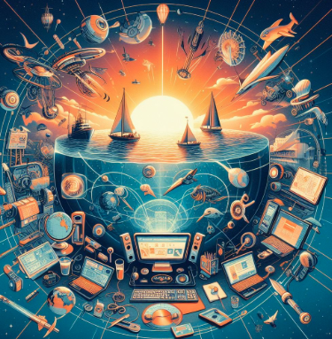
Music-
As musicians we will…
Explore feelings when we play. We will listen to music and focus on the feelings it evokes. We will play music and compare.
We will have a go at simple compositions with our friends. We will use computers to help us with some compositions.

Maths-
As mathematicians
we will…
Y4 - Learn our times tables up to 12 x 12 and the corresponding division facts. We will learn about perimeter and area, fractions and decimals.
Y 5- We will continue to use our multiplication and division knowledge. We will learn more about fractions and decimals. We will learn about graphs, perimeter and area.
Science- As scientists we will…
Learn about circuits and conductors. We will think about what we use electricity for and how to make sure we use it safely. We will construct simple circuits. We will recongnise common conductors and insulators. We will make devises which use a simple circuit. We will learn about some important scientists in the field of electricity, including Michal Faraday, Hertha Ayrton and Nikola Tesla.

PE- As athletes we will…
Focus on tag rugby, gymnastics, dance and hockey. We will focus on movement within different levels. We will continue to learn and practise ball skills and will be working towards playing games of hocket and tag rugby.
French-
As linguists we will…
Learn how to go shopping. So we will learn different fruits and vegetables and what different shops are called in French.
PSHE –
As responsible citizens we will:
Explore the importance of friends. Consider how to identify feelings and manage ‘strong’ feelings.
Learn to be thankful.
Explore E-safety.
Learn how Jesus is our friend.
Explore what to do when things change or feel bad.

th

