# new logoSt Mary’s Catholic Primary School, Buckfast 2025

Our school community seeks to build on Gospel values to:

* Nurture and respect the talents and abilities that God has given to each unique individual.
* Enable everyone to aspire to and realise their potential through perseverance, resilience and integrity
* To grow in love and to be loved, unconditionally.

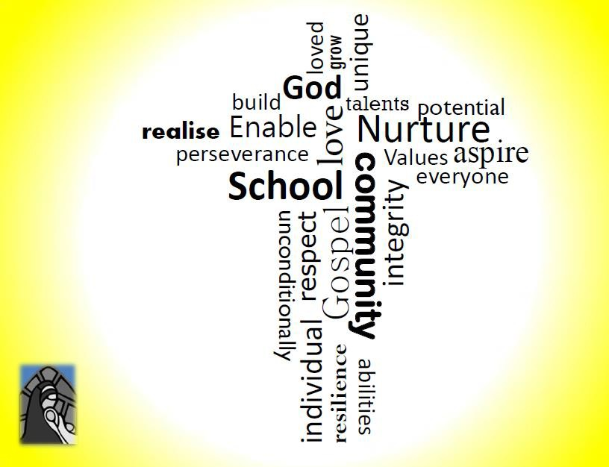

**‘Build, nurture, respect, enable, love unconditionally’.**