RE
As theologians we will…begin by looking at the visit of the Maji, building an understanding of why Matthew wrote this to reveal Jesus being for everybody. We will move on to look at the ‘Our Father’, understand it's meaning and how it teaches us how God wants us to live. Later we will look at the significance of parables and ‘miracles’ and what they teach us about the Kingdom of God. We will understand how Saints were people whose actions lived out the values of the Kingdom of God, finishing by looking at how Christians live out these values and reflecting on the belief that the world belongs to the Lord.
You can help by: Helping your child to learn the ‘Our Father’ by heart.

English
As readers and writers, we will… Use the text ‘Seal surfer’ by Michael Foreman to explore letter writing eventually writing a letter from the boy to his grandfather telling him about the events he has missed We will build a varied and rich vocabulary,learn to use prepositions to express time, place and cause and be Introduced to inverted commas to punctuate direct speech. Alongside this we will have regular SPAG, Handwriting and Guided reading sessions to develop our skills as writers and readers.

You can help by… Ensuring your child continues to learn weekly spellings and are able to practise these on Ed Shed. Encourage them to write letters to friends and relatives and share, where possible, letters you receive to develop their understanding of different forms of letter writing.

Maths
As mathematicians we will… Use Power Maths to Compare multiplication and division statements, use multiplication facts to solve problems, find multiplication and division fact families and learn to multiply using partitioning and expanded written methods. We will move on to Length and perimeter, learning to measure, compare, add and subtract lengths in millimetres and centimetres. We will measure perimeter of shapes and learn about equivalent measures.
Finally, we will look at fractions – finding equivalent fractions, comparing fractions, adding simple fractions to make a whole and finding fractions of amounts.
You can help by: Ensuring ‘mathsflex’ homework is completed, practising the 2, ,3, & 5 times tables, helping secure their Understanding of division as the inverse of multiplication, and helping them link their learning with everyday situations they encounter-ie. Working out the cost of 3 items on your shopping list by multiplying or using language of fractions when dividing a cake.

You can help by:

Science
As scientists we will… begin by identifying and describing the functions of the roots of flowering plants. We will investigate the way in which water is transported within plants, identify and describe the functions of leaves in flowering plants, and explore the part that flowers play in the life cycle of flowering plants, including pollination, seed formation and seed dispersal. We will then look at some of the ways in which flowering plants disperse their seeds and understand the structure of seeds and their importance as a food source.
.
You can help by – discussing plants around your home and how they may have got there (humans/wind/birds) helping them grow a plant of their own and discussing what plants require for good growth.

PE
As athletes we will …
-have Coach George for PE sessions once a week on Tuesday Morning where we will be focusing on Tag Rugny.
We will learn to pass and receive the ball in a safe, controlled manner, looking for suitable gaps and develop attacking, defending and team play skills. On Thursday afternoons we will be focussing on dance. WE will develop our dance skills, learning how to express meaning and create a story with our bodies.

Computing
As digital citizens we will…
Understand how digital devices work, components that make them, how we ae connected using them and how digital devices can help us. We will think about possible dangers of using these online and understand how to stay safe whilst using these devices.
You can help by: encouraging your child to use a computer for their homework and reminding them how to use the internet safely.

History
As Historians we will… understand the terms ‘invade’ and ‘settle’ and place the Romans on a timeline. We will find out why and how the Romans successfully invaded Britain, who was in Britain when they invaded and learn about their way of life. We will then explore who Boudica was from different points of view, find out about the results of Boudica’s revolt and know how the Romans have influenced our lives today.
You can help by… helping your child research evidence of Roman change in our local area and spotting roman inventions in our everyday lives. (eg..Mosaic tiles in kitchen).

Roadford class Curriculum Map
Spring 1 2025

Invaders and Settlers -Romans in Britain
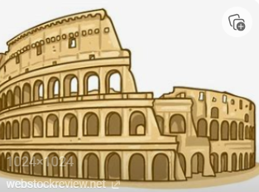

&

How plants grow.

?

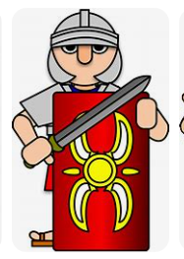

What is the secret of the standing stones?
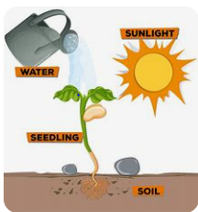
ART
As artists we will… explore the work of textile artists Hannah Rae and Alice Kettle and understand how they use thread, cloth, and paint to make artwork? We will use paint and stitch to create our own works with energy and texture exploring the theme ‘water’ / ‘land’ with the theme of ‘A Roman village’.

Music
As musicians we will … begin the term learning songs and percussion for our Music Day orchestra experience with the Bournemouth Symphony Orchestra. We will then continue with ‘Charanga’ , learning to play in a band and compose with our imagination.
You can help by: Encouraging your child to listen to a range of music and pick out the different voices/instruments that are making up the band.

French
As linguists we will… learn the vocabulary for a range of food. Express likes and dislikes and count and use plural nouns. We will role play a French café/ shop where we will have the opportunity to order and sample French cuisine of our choosing.

PSHE
As global citizens we will… Build on the understanding that we have been created out of love and for love. Children will also learn about different types of sin, and the importance of forgiveness in relationships. We will explore how we take this calling into our family, friendships and relationships and develop strategies for building healthy relationships and keeping safe both online and in our daily lives.

