As theologians, we will explore the overarching theme for this year: "Transformed by Faith." Pupils will delve into stories from scripture, focusing on individuals like Abraham, whose lives were profoundly transformed by their faith and hope in God. We will then study more contemporary examples of people whose faith has had a significant impact on their communities. Through these lessons, pupils will gain a deeper understanding of how faith can shape and influence both individuals and the world around them.

You can help by:
Having moments of reflection with your child to feel closer to God and showing kindness. You can also discuss other faiths.

You can help by:
Having moments of reflection with your child to feel closer to God and showing kindness. You can also discuss other faiths.

As scientists, we will be diving into the fascinating world of light. We will explore how we see light and colours and investigate the concepts of refraction and reflection. Our studies will also cover the light spectrum and the formation of shadows. Through hands-on experiments and observations, we’ll discover how light behaves and how it influences our perception of the world around us.

As readers and writers, we will embark on a whole-school writing project, beginning with "The Midnight Panther."

Following this, we will explore various writing tasks inspired by a reimagined take on "The Three Little Pigs." This will include creating news reports, persuasive speeches, interview scripts, diaries, debates, and narratives. Through these activities, we'll develop our skills in different forms of writing, each inspired by the themes and characters from this classic tale.

In addition to English lessons, we will have dedicated grammar and spelling sessions to further strengthen our literary skills. We will also experience a variety of literature in the classroom, including a poem for every day of autumn, along with our class read. Each day, there will be opportunities for independent reading in class, allowing us to share and recommend the stories we enjoy with each other.

You can help by: Sharing a varied range of literature, listening to your child read everyday and checking they have understood what they have read.

As mathematicians, we will ensure that each day includes a review of prior knowledge, along with daily times tables practice, as a key part of deepening our understanding. We will start the term by focusing on place value, where we'll integrate Year 5 and 6 lessons to reinforce previous learning and address any misconceptions. Towards the end of September, we will begin our unit on the four operations: addition, subtraction, multiplication, and division. This unit will cover topics such as multiplying four-digit numbers by two-digit numbers, understanding square and cubed numbers, and mastering long division. Students will be assessed daily to provide targeted interventions, whether for consolidation or mastery.
You can help by:. Ensuring that your child knows their times tables, can read numbers up to a million and regularly checks Purple Mash for any 2 Do’s.

You can help by:
English
Maths
RE
Science

PSHE
This term we will continue to
focus on supporting children with their feelings through games and activities. Children will understand their rights and responsibilities in the school. Children will have chance to explore what a role model is and how they can be a good example to younger children around the school.
Later in the term, we will explore how we are created and loved by God and how that makes us individual. This gives us the understanding of valuing ourselves as a basis for our personal relationships.

MFL
Computing
In French this term, we will be focusing on two key areas: "Gone Shopping" and the consolidation of basic language skills. In the "Gone Shopping" unit, we'll learn specific vocabulary related to shopping, such as buying clothes and handling French money. Later, we'll reinforce our understanding of fundamental French, including essential phrases and everyday vocabulary. Each lesson will provide opportunities for the children to role-play, helping them to practice their pronunciation and deepen their comprehension of the language.
You can help by practising your French alongside your child’s by asking them what they have learned!

As digital citizens we will be exploring Purple Mash, an educational online tool that enables children to understand computing in today’s world. We will be looking at coding, microbits and building on our previous knowledge followed by online safety.
You can help by: Encouraging your child to use Purple Mash at home to complete any 2Do’s set as well as reinforcing the importance of staying safe online.

You can help by:

You can help by-

Extreme earth
Autumn 1 2024
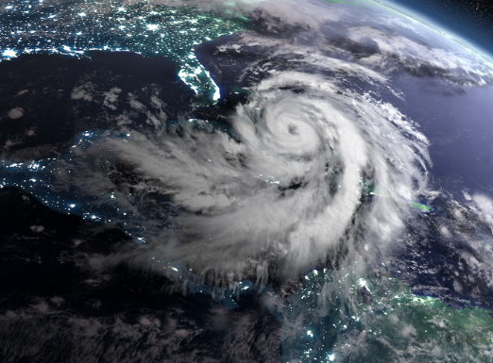

As musicians we will be
understanding how music brings us all together by celebrating a wide range of musical styles. We will be listening, singing, playing, composing, performing and preparing for the celebration of Harvest!
You can help by: Listening to a range of music, discussing the artists and composers and talk about how music has brought people together over time.
Music – Expressive Arts
As athletes we will be continuing to develop our special awareness and coordination football and orienteering.
You can help by, ensuring PE kits and plimsolls/trainers are named, still fit and are in school on Tuesday and Friday.

As artists and designers, we will delve into typography, creating our own fonts and visual elements to communicate ideas and emotions. We will use drawing, collage, and sketchbooks to experiment with different styles. By studying how artists combine lettering with maps to tell stories, we will create our own visual and three-dimensional maps, integrating typography and design elements to express our chosen themes.

As geographers, we will explore "Extreme Earth," focusing on a range of natural phenomena including climates, earthquakes, tornadoes, tsunamis, and volcanoes. We will examine the effects of these events on both the environment and human life.
You can help by researching these extreme phenomena with your child and discussing how they impact different regions, particularly looking into specific examples such as volcanoes and their effects on nearby communities.

PE
Expressive Arts and Design Technology
Geography

