November 2024.

In Venford Class, we have been exploring the beautiful story of the Annunciation from the Bible. This story tells us how God called Mary to be the mother of His Son, and she said a heartfelt “Yes.” Afterward, Mary visited her cousin Elizabeth, who greeted her with the words, “Blessed are you among women.”

We followed Mary and Joseph’s journey to Bethlehem, where God’s great love for us was revealed through the birth of His Son, Jesus. To bring this story to life, we retold it using “Mary’s memory bags” and studied how artists throughout history have depicted these powerful moments in their work.

This week, we’ll continue the story by learning about the angels sent by God to deliver the joyful news of Jesus’ birth to the shepherds. Inspired by this, we will create our own images of angels and come together to make a magnificent group host of angels.

Stay tuned for updates as we bring these stories to life through art, imagination, and reflection!

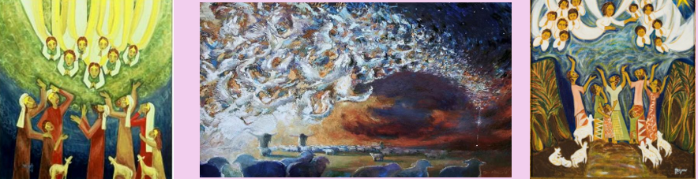

Our host of angels.

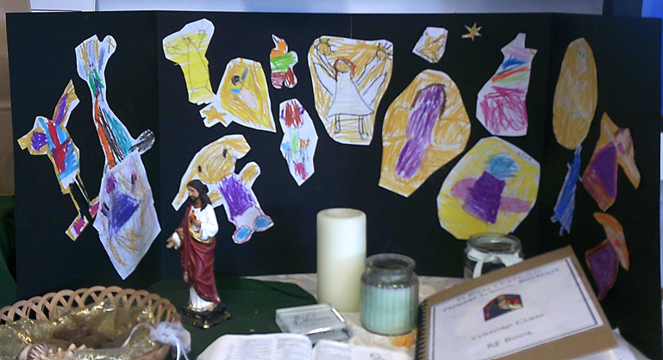

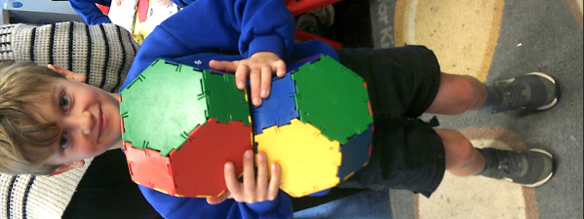We have been getting into the festive spirit by starting to sing our Christmas hymns and rehearsing for our Nativity play. The children are already showing great enthusiasm and joy as they prepare to share this special performance with you.

In **Maths**, we’ve been exploring 2D and 3D shapes. The children have been learning to name and describe these shapes using mathematical language. They’ve particularly enjoyed creating shapes with playdough and Polydron, as well as sorting them in our class Tuff Spot activity.

In **Science**, we’ve been learning about materials, focusing on the difference between objects and the materials they are made from. We are beginning to discover why certain materials are better suited for specific purposes, and the children are asking some great questions as they investigate!

Our History lessons have sparked lots of curiosity as we explored homes from the past. We’ve compared houses from long ago with those of today, noticing the fascinating differences. The children have started making models of their own houses using small boxes. If you have any spare small boxes at home, we would greatly appreciate them to help with this project.

In **Art**, we’ve been inspired by the concept of spirals and explored the work of artist Molly Haslund. The children took this learning outdoors, creating large-scale spirals and circles on the playground—a fun and creative way to develop their understanding of patterns and movement.

It has been wonderful to hear positive feedback about the children’s reading progress. Many of you have shared how confidently they are showcasing their reading skills with their new reading practice books at home. This regular practice is a vital step in building their fluency and confidence. Remember, these books are sent home after the children’s third read in school and should be returned at the start of the next week. They are also available as e-books for added convenience.

Thank you for your continued support at home—whether it’s listening to your child read, sending in small boxes, or encouraging their creativity and curiosity. It all makes a big difference!

In science we have been thinking about materials and understanding the difference between the object and the material it is made from. We will learn why some materials suit certain objects.

The children were really interested in finding out about homes in the past and we talked about the differences between houses from a long time ago and now.

The children are still making models of their houses from small boxes so if you have any at home this would be really useful.

## In art we have been exploring `Spirals ` and looked at the work of the artist Molly Haslund:

We made some outdoor circles on the playground.

It has been lovely to hear lots of positive comments about how the children are `show- casing` their reading skills when they are reading their new reading practice books at home to you. This will really help encourage their fluency and confidence. Try to remember that reading this book at home is a really important part in their reading progression. They are given them after their third read at school and will be collected in again at the start of the next week. They are also available on e books as well.

